What is CrewAI and what value does it add to ORCA?

Right now Agent 1 does demand analysis using one LLM call. The LLM looks at stock levels, velocity, events and produces demand_summary. This works — but it is one LLM doing everything in one shot.
CrewAI lets you replace that one LLM call with a team of specialised agents working together. Each agent has a focused role, its own tools, and its own reasoning. Like hiring specialists instead of one generalist.

For ORCA the forecasting crew would look like this:
CREW — runs inside agent1_node instead of single LLM call

Agent A — Data Analyst
Role: crunch the numbers
Tools: get_sales_velocity, get_store_kpis (from orca.db)
Produces: "demand rising 12% week-on-week across 5 critical stores,
avg daily demand 14.2 units, seasonal pattern detected"

Agent B — Market Analyst
Role: interpret business context
Tools: query_policy_knowledge (your RAG retriever)
Produces: "DSF starts in 32 days — Electronics sees 90% uplift.
TechLine Asia needs 80-day lead. Order window closing."
Agent C — Forecast Strategist
Role: synthesise both into final recommendation
Tools: reads Agent A and Agent B outputs
Produces: demand_summary with richer forecast and confidence score

The final output replaces what the single LLM produced — but it is richer, more accurate, and more explainable because three specialists contributed.

what exactly is CrewAI conceptually before we write a line.
LangGraph = one orchestrator controlling multiple agents sequentially. You designed the flow explicitly. Agent 1 runs, then Agent 2, then Agent 3. You control everything.
CrewAI = a different paradigm. You define agents with roles and goals. You define tasks. CrewAI figures out the execution order and passes outputs between agents automatically. More like a manager delegating to a team.
Think of it this way:
LangGraph = YOU are the project manager. You write the exact workflow.
CrewAI = You hire a team. Each person knows their job.
Team manager (CrewAI) coordinates them.

CrewAI core concepts — from scratch:

Agent — an autonomous worker with a role, goal, and backstory. Knows what it is supposed to do. Can use tools.
Task — a specific piece of work assigned to an Agent. Has a description and expected output.
Crew — a team of Agents with a list of Tasks. Has a process — sequential (one after another) or hierarchical (manager delegates).
Tool — a function an Agent can call to get real data. Same concept as LangChain @tool.

Crew
├── Agent 1 (Data Analyst)
│ ├── Tool: get_sales_velocity
│ └── Task: "Analyse demand patterns for SKU..."
├── Agent 2 (Market Analyst)
│ ├── Tool: query_policy_knowledge (RAG)
│ └── Task: "Research event context and policy rules..."
└── Agent 3 (Forecast Strategist)
└── Task: "Synthesise both analyses into forecast..."

How it connects to ORCA:
Right now Agent 1 in graph.py does a single LLM call to produce demand_summary. CrewAI replaces that single call with a 3-agent crew that produces a richer, more accurate demand forecast. The crew output feeds back into Agent 1's return value — so the rest of the graph (Agents 2, 3, 4) is completely unchanged.

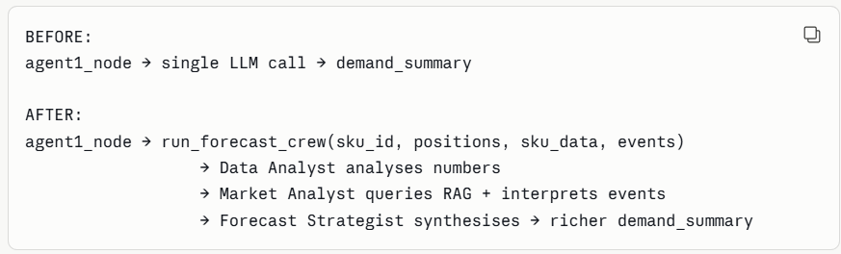
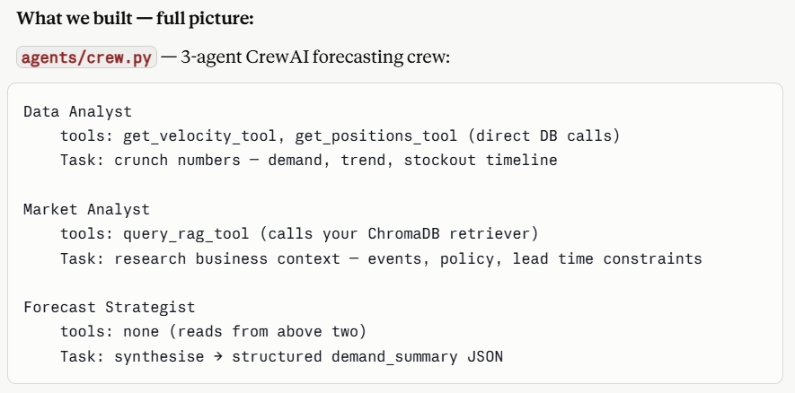

Q: just clicked my mind when i saw the term "forecast". generally in use case like orca, there should ve some forcasting using ML right? it will make ORCA more robust use case ?? just thought he he he
"ORCA uses a lightweight LLM-based forecasting approach via a CrewAI crew rather than a traditional ML model. The Data Analyst agent analyses rolling velocity metrics and trend data computed by our pandas transform layer. In a production extension, this would be augmented by an ARIMA or Prophet model trained on 2+ years of history — the agent would consume those ML forecasts alongside live stock data. The architecture is already designed for this — we would just add a forecast_demand column to curated_skus and the agents would read it automatically."
That answer shows you understand the full picture — where ML fits, why it is not here, and how you would add it. That is more impressive than just having a basic scikit-learn model.

